Currents of Thought Part I
Try this program to help fill organizer - http://flashnhistory.com/FlashPrograms/CurrentsofThought.swf
Famous Person | Dates | Accomplishments
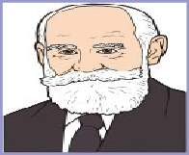  Ivan Pavlov | 1849 - 1936 | Conditioned responses from dogs using bells at feeding.  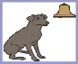
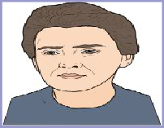  Marie Curie | 1867 – 1934 | Won Nobel Peace Prize by working breaking down pitchblende which produced two new elements. Radium and Polonium
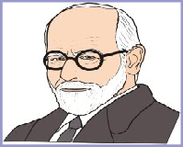  Sigmund Freud | 1856 – 1939 | Examined the concepts of the unconscious, and repression Treated patients with psychoanalysis.
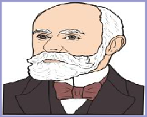  Henri Becquerel | 1852 – 1908 | Investigated nuclear radiation by studying the unusual properties of the element uranium.
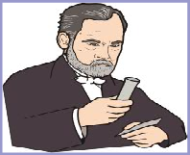  Louis Pasteur | 1822 – 1895 | Discovered bacteria could be killed by pasteurization - heat - Developed the first vaccine for rabies and anthrax.
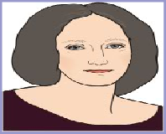  Mary Shelley | 1797 – 1851 | In the book, Frankenstein had created a monster who was a symbol of science trying to conquer nature.
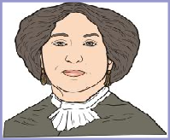  George Sand | 1804 – 1876 | Famous writer who is remembered for wearing men's clothing and smoking in public. Lover to musician Chopin.
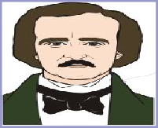  Edgar A. Poe | 1809 – 1849 | Invented the detective story and formulated the short stories with works like "The Tell-Tale Heart and Murders in the Rue Morgue."
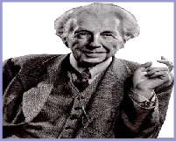  Frank Lloyd Wright | 1867 – 1959 | America's architect designer of homes like Falling Water, museums like the Guggenheim and office buildings like the Larkin and Johnson Wax.
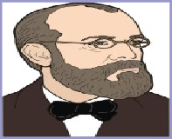  Robert Koch | 1843 – 1910 | Prussian scientist, who discovered anthrax bacteria - the cause of hoof and mouth disease. Considered one of the founders of microbiology.
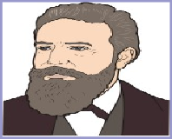  Wilhelm Roentgen | 1845 – 1923 | German physicist, who, produced and detected electromagnetic radiation in a wavelength range today known as X-rays.
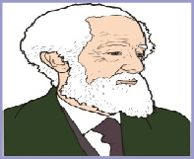  Dmitri Mendeleev | 1834 – 1907) | Russia chemist, who organized a chart where elements are arranged by weight - periodic table of elements.
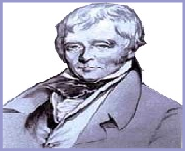  Sir Walter Scott | 1771 – 1832 | Wrote historical novels like Ivanhoe. A time of turmoil and hatred between the Normans and the Saxons.
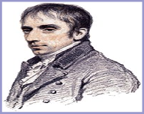  William Wordsworth | 1770 – 1850 | Started the Romantic Age in English literature with "I wondered lonely as a cloud" in 1804 "Daffodils."
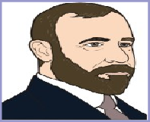  Louis Sullivan | 1856 – 1924 | American architect who has been called the "father of skyscrapers." Mentor to youger members of the Prairie School.

Currents of Thought Part 2 – The Age of Progress 2
The program for this organizer can be found at http://flashnhistory.com/FlashPrograms/CurrentsofThought2.swf
Famous Person | Dates | Accomplishment
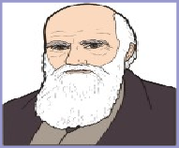  Charles Darwin | 1809 – 1882 | In the, On the Origin of Species, he presented the theory of evolution. Based on research from Galapagos Islands.
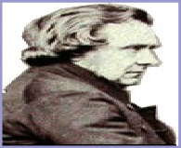  Samuel Wilberforce | 1805 – 1873 | British religious leader said the theory of evolution contradicted the Bible and also denied God's role in creation.
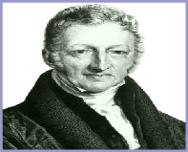  Thomas Malthus | 1766 – 1834 | In his Essay on Population, human population grows faster than food production. Disease and famine keep population in check.
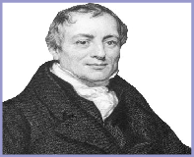  David Ricardo | 1772 – 1823 | Developed the Iron Law of Wages. When workers make more money in the cycle, they have more children.
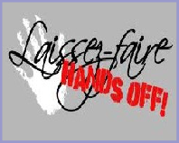  Laissez-faire | Omit | Theory used by industrialists, to keep government and unions out of their businesses so they could run it their way.
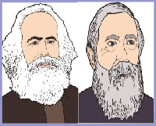  Marx and Engels | KM - 1818 – 1883  FE - 1820 – 1895 | Workers of the world, unite. The Communist Manifesto urged worker to rise up against those who oppressed them.
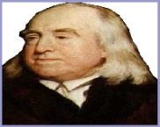  Jeremy Bentham | 1748 – 1832 | Philosopher who thought efforts should be made to improve the living and working conditions for workers.
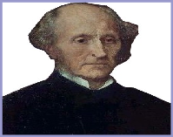  John Stuart Mill | 1806 – 1873 | Reformer who called for Labor Unions to improve working conditions. Both men and women should be able to vote and have an education.
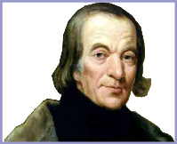  Robert Owen | 1771 – 1858 | Founded an industrial community in New Lanark, Scotland where he made a profit and workers were paid and treated well.
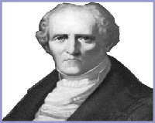  Charles Fourier | 1772 – 1837 | A utopian socialist, who built several communities in France and U.S. where workers shared profits and did what they do best. All failed.
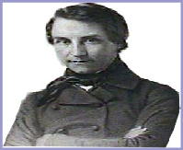  Louis Blanc | 1811 - 1882 | French journalist, called for the government to organize workshops run by workers -based on "from each according to ability."
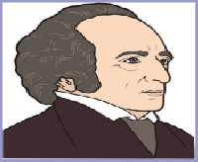  Gregor Mendel | 1822 – 1884 | Austrian monk investigated how biological characteristics are passed on. Peas became the basis for laws of heredity.
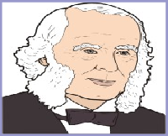  Joseph Lister | 1827 – 1912 | English surgeon, who worked on the problems of infection after surgery. He developed ways to kill bacteria. Yes, Listerine is named after him
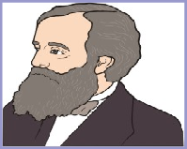  James Clerk Maxwell | 1831 – 1879 | Scottish physicist, who predicted that electric and magnetic energy moves in waves at the constant speed of light.
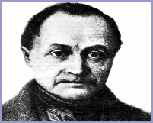  Auguste Comte | 1798 – 1857 | French philosopher was one of the founders of sociology. Society had laws like nature and operated accordingly.

